**Date: 11 July 2020 Time : 90 Mins**

Instructions:

• Give project name as yourname_year_number(Ex. Rohinth_2020_001)

• Use exactly same class names as mentioned

• Use exactly same method signature (method name, return type, method parameter type, position of each method parameter)

• Define attributes with same name and data type as given in class outline.

• Define constructors and getter setters as given in the class outline.

• Ensure attributes are private and other methods which will be called from main method, getter-setter methods and constructor are public.

• Use main method only for input and output and testing object creation and object methods.

• Within the given time, mail it

**As mentioned above, any logic which may be 100% correct is not valid if above points are not taken care. Hence, simply building logic does not certify us as project ready. Building exact and complete solution does.**

**Problem Statement:**

Training and Placements department of a university planned to automate the student details management process. To assist them, develop a system based on the below mentioned requirements.

Create class **Student** with the following attributes.

regNo – int, name – String, branch – String, cgpa – float, placementStatus – boolean and company - String

**Create constructors, getters and setters as mentioned in the project view image at the end of this file.**

Create **TnPManagement** class with main method.

In main method create array of Student objects with the following values.

**regNo name branch cgpa placementStatus**

1001 A EEE 6.5 false

1002 B ECE 7.5 false

1003 C EEE 5.5 false

1004 D CSE 8.5 false

1005 E ECE 7.5 false

1006 F EEE 6.5 false

In the same class create the following methods with specified requirements.

1. **getEligibleStudents()** – This method accepts array of Student objects, branch and cgpa as arguments. This method returns all the eligible students in the given branch, who have cgpa greater than the given cgpa and placementStatus is false.

2. **getPlacedStudentsCount()** – This method accepts array of Student objects and returns total number of students got placement offers (placementStatus is true).

3. **getStudent()** – This method accepts array of Student objects and regNo of a student.

It searches the student in the array and returns the student object, if student not found returns null.

4. **updatePlacementStatusAndSort()** – This method accepts array of Student objects, the regNo of the student and Company name as arguments. This method searches the student with the given register number in the array of objects and updates his placement status as true and company details. Then sort the array of object based on the cgpa value and returns the sorted students list.

**Test all the above methods with the given sample inputs from main method. Project View:**

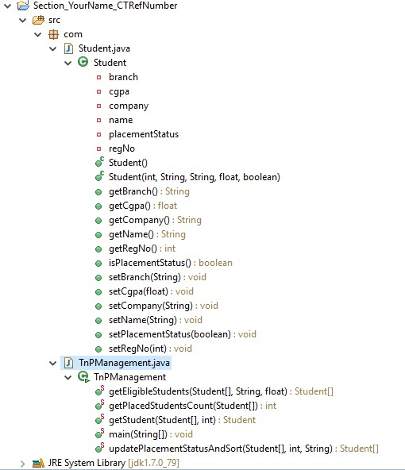

**Zip Procedure:**

**1. In eclipse right click on your project.**

**2. Select copy, then on desktop paste it.**

**3. Now, on desktop your project folder will be available. Right click that folder and select, send to -> compressed folder.**

**4. Now you can find compressed file (zip) of your project folder.**